Alyssa Yamraj
NYPD Misconduct Research Taskforce
Individual Project
Professor West & Professor Umbach

Looking at the records of police misconduct located in the NYPD Files on propublica.org, there is a fair number of allegations that have been made by white people. If that is the case, then how do those allegations differ from those made by people of color? I want to further analyze how allegations made by white people differ from those made by people of color throughout the years 2010 to 2018. To specify further, I’d like to focus on allegations made due to an officer’s abusing their authority, and the sub-category frisk. There are 1,926 allegations against officers in this sub-category for abuse of authority. These allegations are made by all types of people: Whites, Blacks, Hispanics, Asians, and American Indians.
There are numerous categories that allegations are sorted into which include Force, Abuse of Authority, Discourtesy, and Offensive Language. From these categories, there are further sub-categories in which, for example, the type of alleged force is stated, along with a specific number of allegations. This is the same for the general four categories. Upon entering a specific sub-category, it will state the police officer’s name, rank at the time the complaint was issued, officer ethnicity, complainant ethnicity, the CCRB’s conclusion and the year the case was received.
Before I proceed further, it is important to mention that all data is imperfect; naturally there will be problems with data. There is data that is accurate, however, methods of data collection are changing all the time. Not only with the data, but the people collecting the data are changing overtime as well. A prime example of this would be the CCRB (Civilian Compliant Review Board) changing who is reviewing complaints as they see fit. At one time, there was a mix of members on the board, consisting of private citizens and police officers. This was to rule out chances of bias among the data. However, things such as this cannot always be avoided. In addition, where data is collected from (where it is based upon) also experiences changes overtime. For example, the police force in NYC in the past is nothing compared to the present. Before, the majority were white people, now there are more people of color on the force than not, showing a composition change that definitely affects data in the long run.
My Findings:
Generally, in looking at any data, there are many conclusions that can be made. As mentioned before, focusing on allegations made in Abuse of Authority in the sub-category frisk, there are 1,926 allegations against officers. However, when looking at the data, there is a total of 1,704 allegations made against officers from Whites, Blacks, Hispanics, Asians, and American Indians. In the data, for ethnicity, there are spots where “UNKNOWN” is filled out. This means that the other 222 allegations are made by people whose ethnicities are not known. This is a gap in the data that can’t be helped.
A conclusion that can be made from the data found and analyzed is that, while the number of allegations made by whites fluctuates, the number of allegations made by people of color, mainly Black people, is consistently above 50. This is not a surprise, as Black people make up majority of all allegations, not just in the sub-category Frisk. In addition, another way this can be seen/stated is that while the number of allegations made by whites declined, the percentages of the people of color has not. To give some insight through numbers, white people make up 7.3% of all frisk allegations. Black people, on the other hand, make up 67.2% of all frisk allegations. Hispanic people make up 23.5% of all frisk allegations, also significantly higher than those made by whites. 1.5% of all frisk allegations is made up of Asians, and 0.5% is made up of American Indians.
Below is some of the data I was able to find:

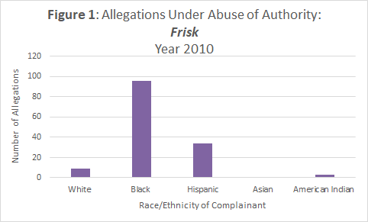

Note: Allegations made by:
Whites: 9, Black: 96, Hispanic: 34, Asian: 1, American Indian: 3

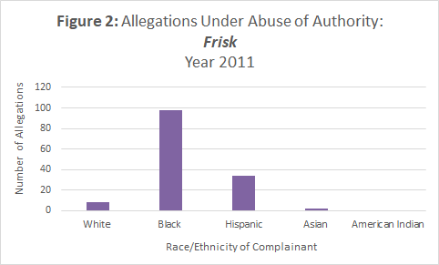

Note: Allegations made by:
Whites: 8, Black: 98, Hispanic: 34, Asian: 2, American Indian: 0

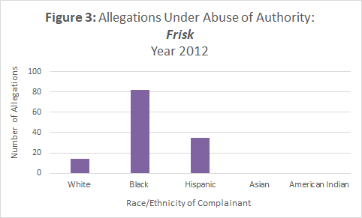

Note: Allegations made by:
Whites: 1, Black: 82, Hispanic: 35, Asian: 0, American Indian: 0

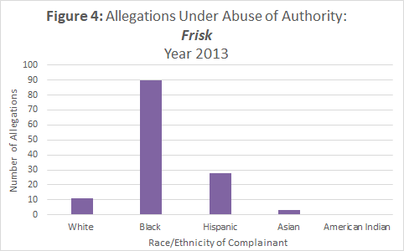

Note: Allegations made by:
Whites: 11, Black: 90, Hispanic: 28, Asian: 3, American Indian: 0

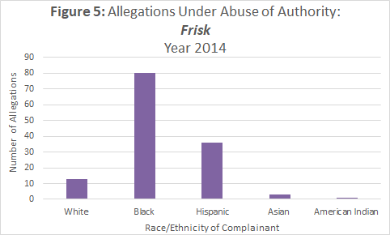

Note: Allegations made by:
Whites: 13, Black: 80, Hispanic: 36, Asian: 3, American Indian: 1

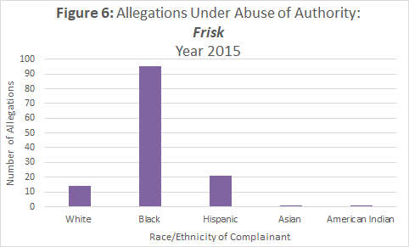

Note: Allegations made by:
Whites: 14, Black: 82, Hispanic: 25, Asian: 7, American Indian: 1

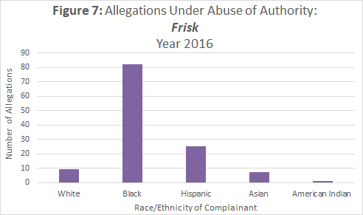

Note: Allegations made by:
Whites: 9, Black: 82, Hispanic: 25, Asian: 7, American Indian: 1

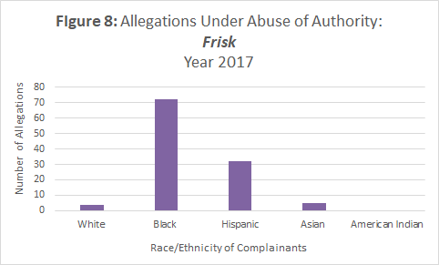

Note: Allegations made by:
Whites: 4, Black: 72, Hispanic: 23, Asian: 0, American Indian: 2

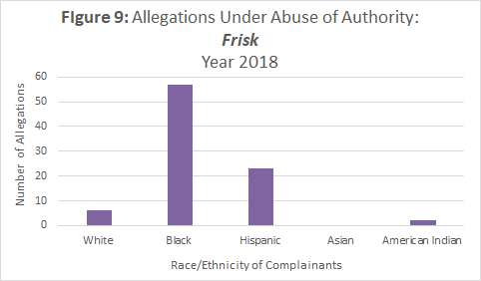

Note: Allegations made by:
Whites: 6, Black: 57, Hispanic: 23, Asian: 0, American Indian: 2

Source: ProPublica, available at https://www.propublica.org/datastore/dataset/civilian-complaints-against-new-york-city-police-officershttps://www.propublica.org/datastore/dataset/civilian-complaints-against-new-york-city-police-officers

