Anglique Beharry

Topic Question: Differences of allegations among the ranks of officers ?

The NYPD are an essential part of NYC. Police officers of different ranks interact with civilians on an everyday basis. With these interactions it can range from good to bad. The CCRB has 4 main allegations that individuals can make against the NYPD officers. Each rank of officers vary in the complaints that are filed against them.

Use of Force by Member Service by Rank:

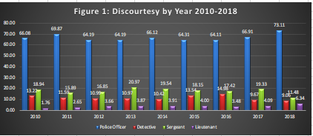

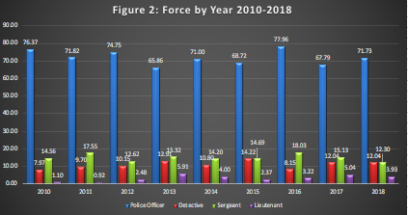

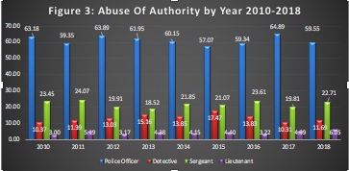

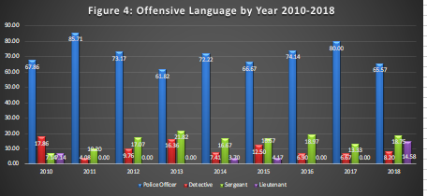

Analysis:

As you can see a common thread that you can identify in all fours graphs is patrol officers are more commonly complained against. But what was interesting is that sergeants are the second highest being complained about within the complaints. Third on the ranking would be detectives and fourth would be the lieutenants.
Further Conclusions:

I proceeded to do further research to further understand why the data may look like this. When talking a look into the patrol officers’ jobs and each ranks responsibility, it can further explain the graphs.

A detective is in charge of many things ranging from homicides, etc. A sergeant is a supervisor for the patrol officers, which could further explain why they’re the second highest when complaints are concerned. A lieutenant supervises the daily work. He/she evaluates the work of his officers and review the concerns pertaining to first line officers. Other responsibilities include coordinating scenes, securing evidence, directing arrests processing and the holding of prisoners.

The amount of interaction that these officers have with civilian the number of complaints that are being made. The complaints tend to stay around the same range each year for each type of allegation.

Work Cited
Zander, J.A. Duties of the NYPD Ranks. 29 June 2018, work.chron.com/duties-nypd-ranks-21851.html.

