Vivien Dudas 12-03-2020

For this project, my research question is whether the type of force allegations vary by race. This research is based on Civilian Complaint Review Board (CCRB) data to see if there are differences in the allegations based on the complainants’ race.

Since 2008 there were 927 allegations between 2008 and 2018 of ‘Force.’ Since physical “force” is a broad category, this research looked at specific kinds of allegations of force to better understand potential variation of the use of force by race. The specific subcategories are:
- Gun Pointed
- Nightstick as Club
- Chokehold
- Handcuffs too Tight
- Gun as Club
- Gun Fired

I purposely wanted to look at a category as serious as gun fired or chokehold and as minor as handcuffs being too tight to really be able to compare the outcomes of each situation based around the complainants’ race.

I looked at each category for the past 10 years, 2008-2018. I decided not to look at the last 2 years as these cases may still be ongoing thus not providing me with accurate information.

The table below shows the data I found during my search.
TABLE 1, Percent by Race and Ethnicity
 | Gun Pointed | Nightstick as Club | Chokehold | Handcuffs too tight | Gun as Club | Gun Fired
Black | 44.6 | 20.1 | 23.1 | 6.4 | 2.5 | 3.4
Hispanic | 41.8 | 24.1 | 25.0 | 6.4 | 1.4 | 1.4
White | 47.5 | 18.0 | 26.2 | 8.2 | 0 | 0
Asian | 40.0 | 20.0 | 40.0 | 0 | 0 | 0
Other | 25.0 | 33.3 | 29.2 | 12.5 | 0 | 0
Not Available | 82.4 | 5.9 | 5.9 | 5.9 | 5.9 | 5.9
Unknown | 40.6 | 34.4 | 9.4 | 3.1 | 9.4 | 3.1
Total Number of Allegations | 409 | 199 | 216 | 60 | 20 | 23
Source: ProPublica, available at https://www.propublica.org/datastore/dataset/civilian-complaints-against-new-york-city-police-officers

The majority of complaints across all categories were filed by black people, or people of color in general. I believe the most noticeable difference in races is between “gun pointed” and “chokehold”.
Although the subcategories “gun as club” and “gun fired” also had a large division between the complainants’ race, the sample size was too small for it to accurately represent the data findings.

Below, you can see the statistics of the subcategories; gun pointed and chokehold.

Each bar is represented as the percentage of allegations made by each race.

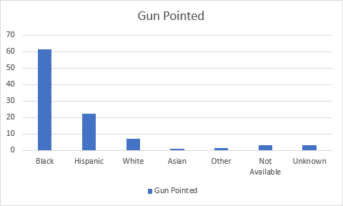
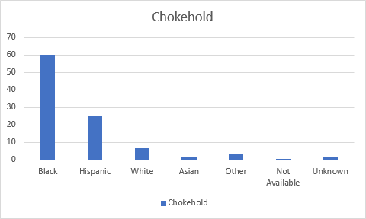

The bars help us realize the large differences between people of color and non people of color. In both cases, over ¾ of the complainants were black or Hispanic people.

